Psychotropic Medication Training
*Recommend using Chrome*
Create account with My FL Learn – Training Portal
https://www.myflfamilies.com/my-fl-learn
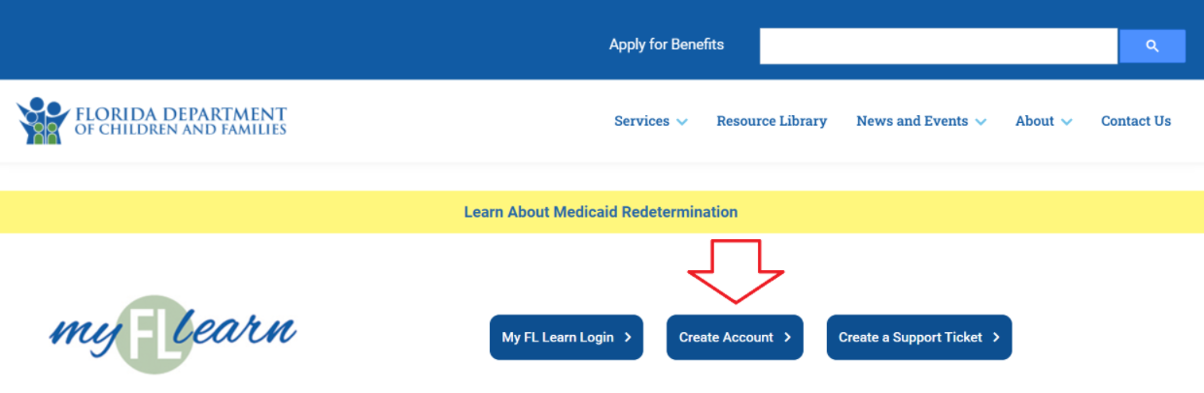

Both applicants must complete and provide a certificate!
If you are not able to view together, please create separate accounts.

If you view the training together, you may opt to create a joint account. Include both names when registering in the first name box.
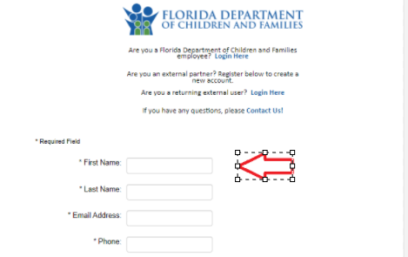
Open Locationtype Polk, click search, click Polk
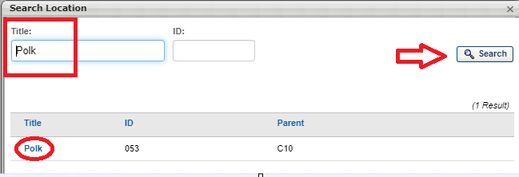

Open Division type Heartland for Children, click search, click Heartland for Children
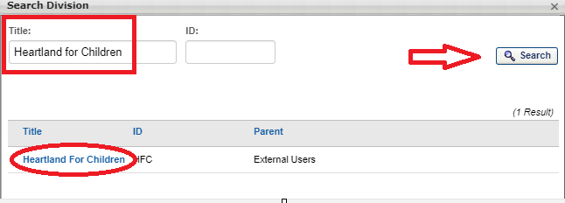
Use drop-down arrows to select as follows:
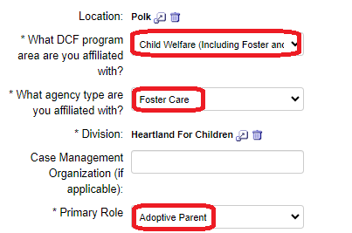
Create password. Log In.
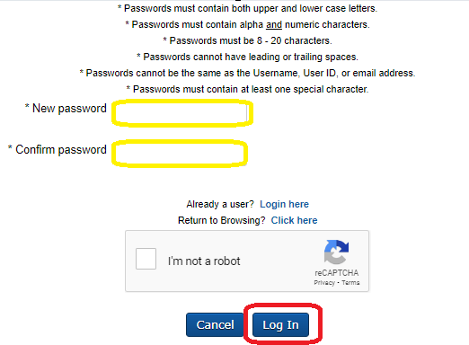
Once logged in, search Understanding Psychotropic Medications
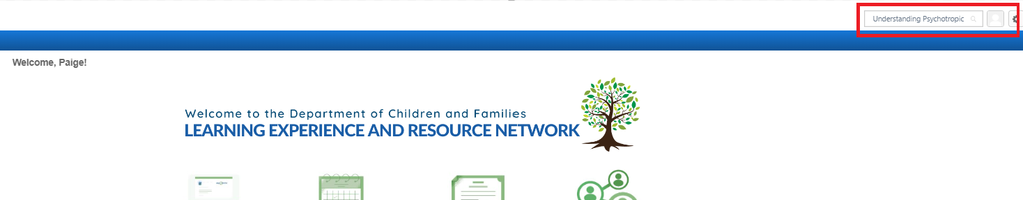

Complete the training
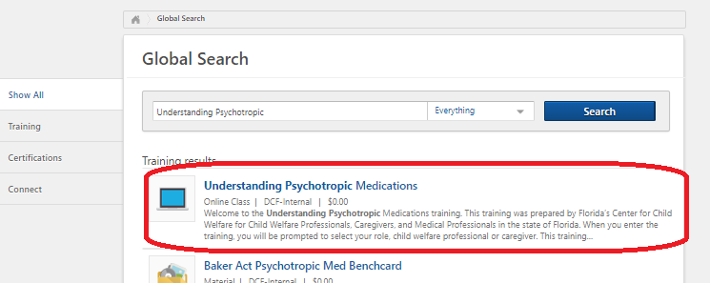
Email certificate to pross4@heartlandforchildren.org
(screenshot, pdf, printed scanned or clear photo are all acceptable)

