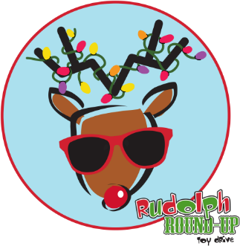

Dear Rudolph Champion,

Thank you for participating in Heartland for Children’s 20th Annual Rudolph Round-Up Holiday Toy Drive by sponsoring a child’s wish list! Through your generosity and commitment, you are helping to brighten the lives of over 1,500 children in the foster care system throughout Polk, Highlands and Hardee Counties this holiday season.

**Step #1: Purchase Gifts for Child(ren)**

Each child has submitted a wish list that consists of 2-3 holiday wishes equaling up to $100 in value. We ask that our donors do their best to fulfill the child’s wish lists.

Attached is a wish list for each child you have sponsored, which includes:

* Child’s first name
* Rudolph identification number
* Gender and age
* The child’s likes, interests, and clothing sizes may also be listed to help you in shopping for their wishes.

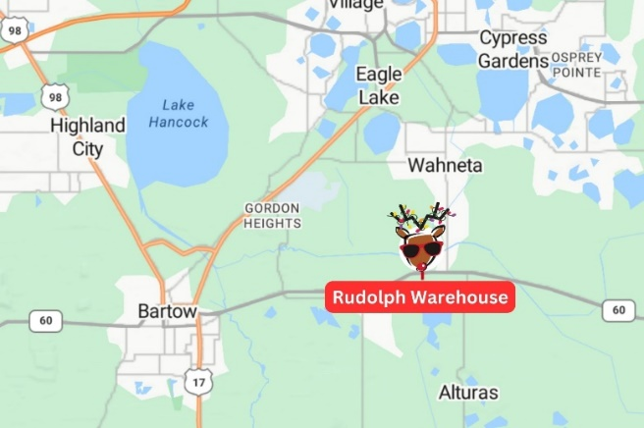When fulfilling wishes please refrain from including personal notes and candy or food items with the gifts,

as some children have food allergies.

**Step #2:** **Fill the Form**

On the bottom of each wish list is an area for donor information.

Please complete the requested donor information at the bottom of each wish list.

* Print this information legibly
* Place the child’s unwrapped gifts in a bag (any type will do) and attach the wish list securely.

**Step #3: Drop Off Gifts**

Once the wish list(s) have been fulfilled, the gifts are the be dropped off at our Rudolph Warehouse.

**Rudolph Warehouse**

Heartland Youth Village (also can be looked up as Florida Sheriff Youth Villa)

3350 E State Rd 60, Bartow, FL 33830 (directly across the street from Peace Creek Baptist Church)

* It will be the first building on your right. Please follow the “Drop Off” signs
* Upon arrival, call 863-272-8326 and a Rudolph team member will meet you outside the drop off door.

*If you are unable to bring the gifts to the Rudolph Warehouse*,

* Please contact Shawna Butler directly to arrange a pick-up date and time.
* For those interested in contactless delivery, please mail gifts to:
  + Shawna Butler, Heartland for Children
  + 1239 E Main Street, Bartow, FL, 33830
  + If you choose to utilize this option, please be sure to include your Donor ID, the child’s first name and Rudolph identification number as this allows us to ensure it gets to that assigned child.

**Due Dates:** We ask that you drop off the fulfilled wish list(s) as early as possible during the period noted below.

If you received your wish list(s):

* If you received your wish lists **before** Thanksgiving, your due date is **Saturday, December 7th**
* If you received your wish lists **after** Thanksgiving, your due date is **Friday, December 13th**

**Warehouse Dates/Times:**

Pre-Thanksgiving:

* Monday, November 18th - Friday, November 22nd (9:30AM-5:00PM)

**Thanksgiving Week: CLOSED**

Post-Thanksgiving:

* Monday, December 2nd – December 6th (9:30AM- 5:30PM)
* Saturday, December 7th (9:30AM-2:00PM)
* Monday, December 9th – December 13th (9:30AM – 5:30PM)
* Saturday, December 14th (9:30AM-2:00PM)

If you have any questions, please contact me at [rudolph@heartlandforchildren.org](mailto:rudolph@heartlandforchildren.org) or call 863-450-8325.

Sincerely,

Shawna Butler

Director of Community Relations