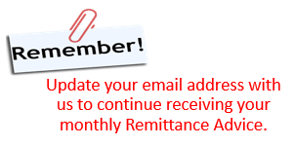

Date: December 01, 2017
To: Foster Parents
From: Finance Department
Re: Foster Care Board Payments for the Calendar Year 2018

Please see our 2018 schedule for foster care board payments, which are paid out on the 2nd Tuesday of each calendar month. The dates for the 2018 schedule are listed below as well as on our website:

Month of Service 2018 Payment Dates

January 01/09/18
February 02/13/18
March 03/13/18
April 04/10/18
May 05/08/18
June 06/12/18
July 07/10/18
August 08/14/18
September 09/11/18
October 10/09/18
November 11/13/18
December 12/11/18

Should you have any questions or concerns about payments, kindly contact our office at the number listed below. We wish you and your family a very Happy Holiday season!

Shibani Kyani
Director of Business Affairs
Tel: (863) 519-8900 extension 203
Email: SKyani@HeartlandforChildren.org

